Git Hands-On Lab
Aim:
To learn the basic Git commands by configuring Git, creating a local repository, adding a file, committing changes, and pushing the repository to GitHub.
Tools Required:
- Git Bash
- GitHub Account
- Notepad++
- Windows PC
Procedure:
- Installed Git and verified the installation using git --version.
- Configured Git username and email.
- Configured Notepad++ as the default Git editor.
- Created a local Git repository (GitDemo).
- Created a file named welcome.txt.
- Added the file to the staging area using git add.
- Committed the file using git commit.
- Created a remote GitHub repository (GitDemo).
- Connected the local repository to GitHub.
- Pushed the project to GitHub using git push.
Commands Used:
- git --version
- git config --global user.name "Sravanthi"
- git config --global user.email "your_email@gmail.com"
- git config --global core.editor "notepad++.exe -multiInst -nosession"
- git init
- echo "Welcome to the version control" > welcome.txt
- git status
- git add welcome.txt
- git commit
- git remote add origin https://github.com/Sravanthi-36/GitDemo.git
- git branch -M main
- git push -u origin main

Fig. 1: Git version verification and Git user configuration
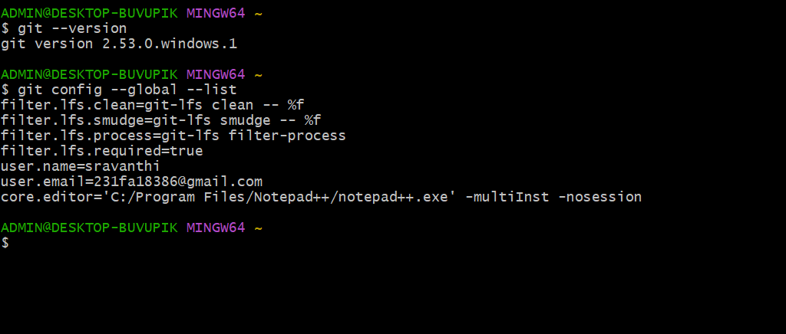

Fig. 2: Notepad++ configured as Git default editor
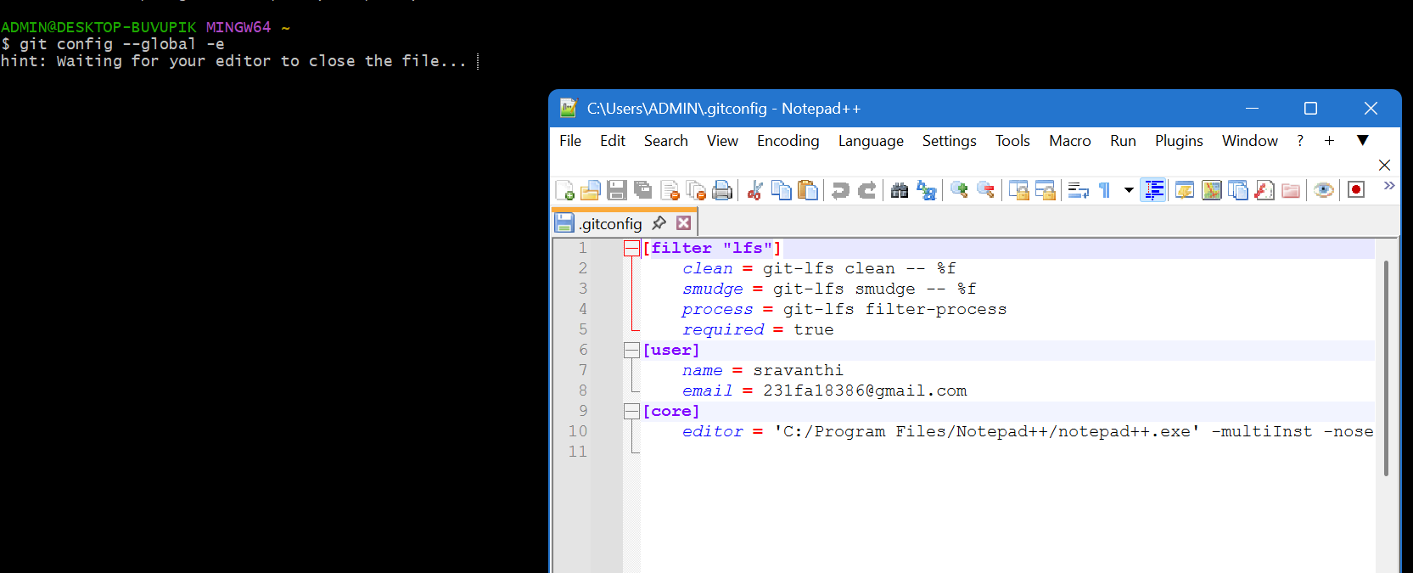

Fig. 3: Creation of welcome.txt
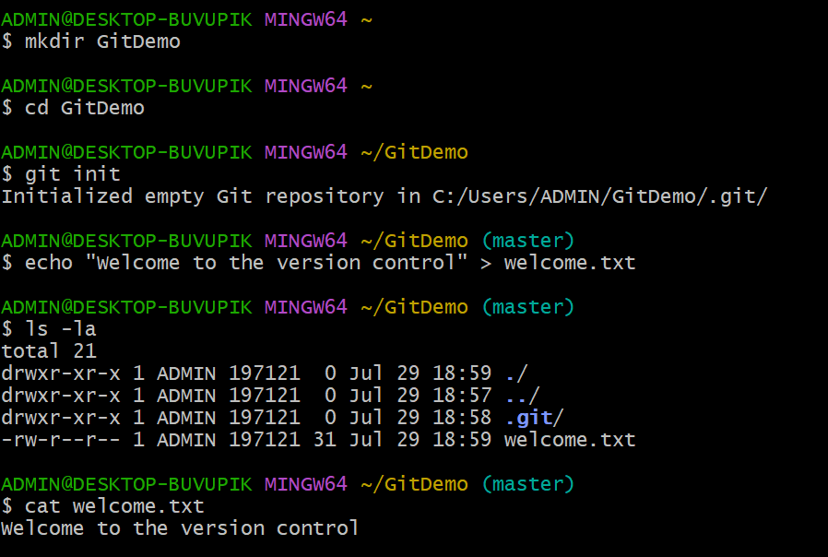

Fig. 4: GitHub authentication successful

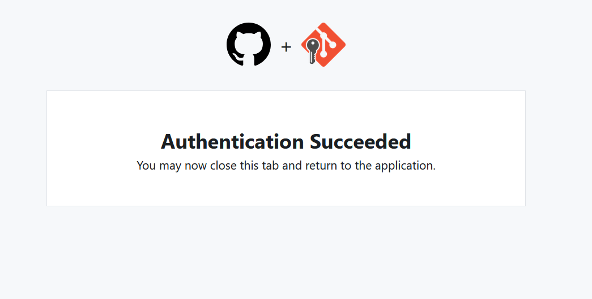

Fig. 5: GitHub repository showing welcome.txt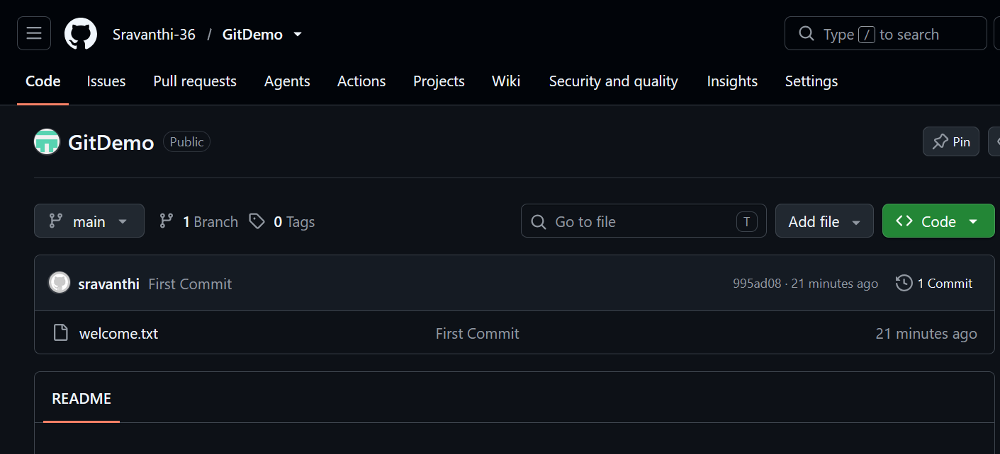

Result:
Successfully configured Git, created a local repository, committed a file, and pushed the project to the GitHub remote repository

